ANJI BRIDGE

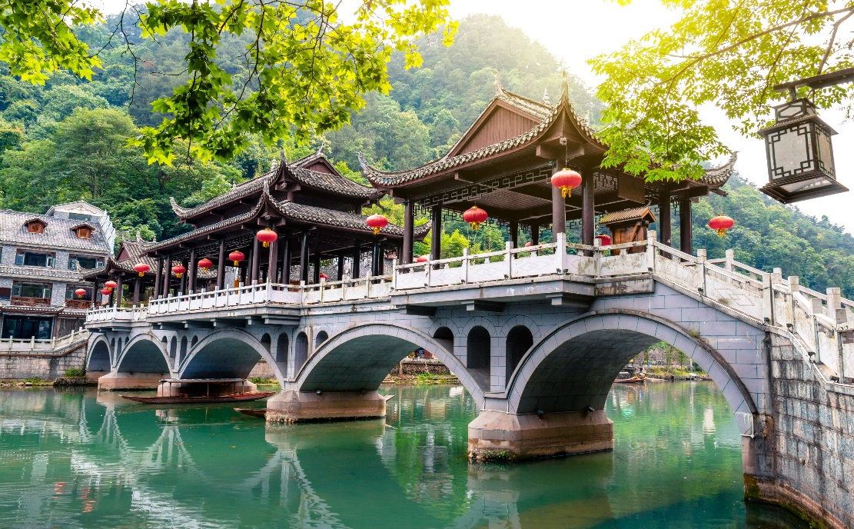

The Anji Bridge, also known as Zhuzhou Bridge, is a masterpiece of ancient Chinese engineering that has stood the test of time for over a millennium. Located in Hebei Province, China, this stone arch bridge was completed in the 7th century during the Sui Dynasty, making it one of the oldest and most well-preserved bridges in China. Spanning the Xiao River with a single graceful arch measuring over 50 meters (164 feet) in length, the Anji Bridge is renowned for its elegant design and remarkable structural stability. Constructed using a sophisticated system of interlocking stones without the use of mortar, the bridge has weathered centuries of earthquakes, floods, and wars, a testament to the ingenuity and craftsmanship of its builders. Beyond its functional purpose of facilitating transportation, the Anji Bridge holds significant cultural and historical significance, serving as a symbol of China's ancient engineering heritage and enduring resilience. Today, it continues to inspire admiration and awe among visitors, drawing scholars, artists, and tourists alike to marvel at its timeless beauty and craftsmanship. The bridge's enduring presence has inspired countless poems, paintings, and literary works, becoming a cherished symbol of harmony between humanity and nature. As a UNESCO World Heritage Site and a revered national treasure, the Anji Bridge continues to evoke a sense of awe and reverence, serving as a living testament to the timeless wisdom and cultural legacy of ancient China.